Тема: Введение лексики по теме «Мой дом, моя квартира».

[w]: Wall, wardrobe, window
[tʃ]: Chair, armchair, picture, kitchen
[t]: Table, carpet, computer, TV
[ð ]: There is, there are, this, that
[Ɵ]: Bath, bathroom, three, thank
Vocabulary:
Flat – квартира
Living room [ˈlɪvɪŋ] –гостиная
Dining room [daɪnɪŋ] - столовая
Bedroom [ˈbedrum] - спальня
Bathroom [ˈbɑ:θrum] - ванная
Kitchen [ˈkɪtʃɪn] - кухня
House [haus]- дом
Window [ˈwɪndəu]- окно
Bed [bed] - кровать
Lamp [læmp]- лампа
Table [ˈteɪbl]- стол
Wall [wɔ:l]- стена
Picture [ˈpɪktʃə]- картина
Bookcase [ˈbukkeɪs]– книжный шкаф
Bookshelf [ˈbukʃelf]- книжная полка-
Wardrobe [ˈwɔ:drəub]- шкаф
Chair [tʃɛə]- стул
Armchair [ˈɑ:mˈtʃɛə] - кресло
coffee table — журнальный столик
floor — пол
armchair — кресло
lamp — лампа
window — окно
curtains — занавески
sofa — диван
pillow — подушка
ceiling — потолок
TV set — телевизор
picture — картинка
fireplace — камин
Carpet [ˈkɑ:pɪt]- ковер
Study- кабинет

Опишите картинку подставив в текст использовав слова из Vocabulary Вариант картинки определяется по начальной букве вашей фамилии.

№1 Фамилии начинающиеся с А по Д
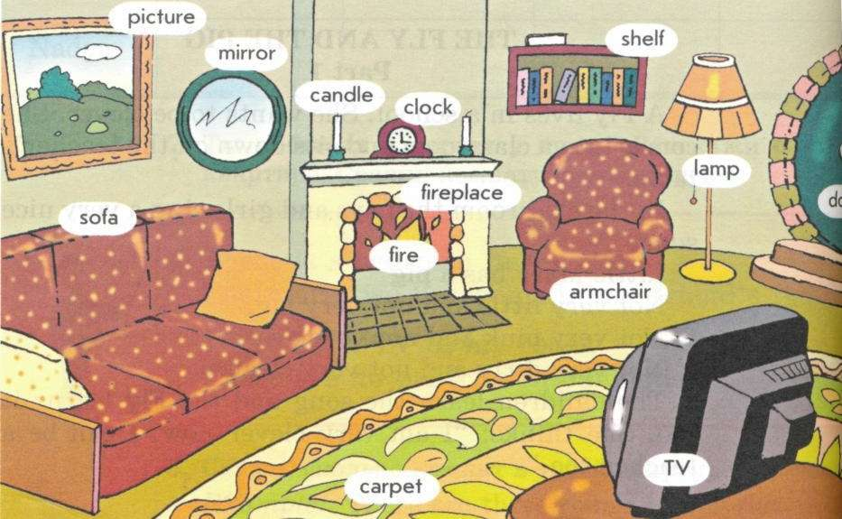

I live in a……
There are __rooms
Living room is my favorite room.
It is nice / large.
There is/are……in the room.
On the left there is/are…..
On the right there is/are……
In the middle of he room there is/are….

№2 Фамилии начинающиеся с Е по К

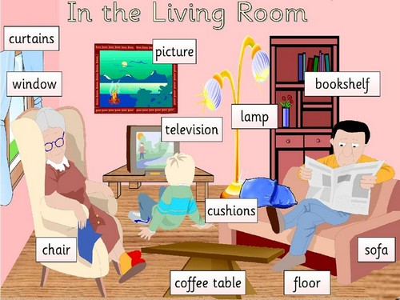

I live in a……
There are __rooms
Living room is my favorite room.
It is nice / large.
There is/are……
On the left there is/are…..
On the right there is/are……
In the middle of the room there is/are…..

№3 Фамилии начинающиеся с Л –П

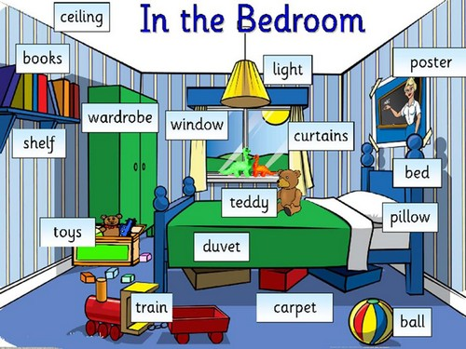
I live in a……
There are __rooms
Bedroom is my favorite room.
It is nice / large.
There is/are……
On the left there is/are…..
On the right there is/are……
In the middle of he room there is/are…..

№4 Фамилии начинающиеся с Р по Х
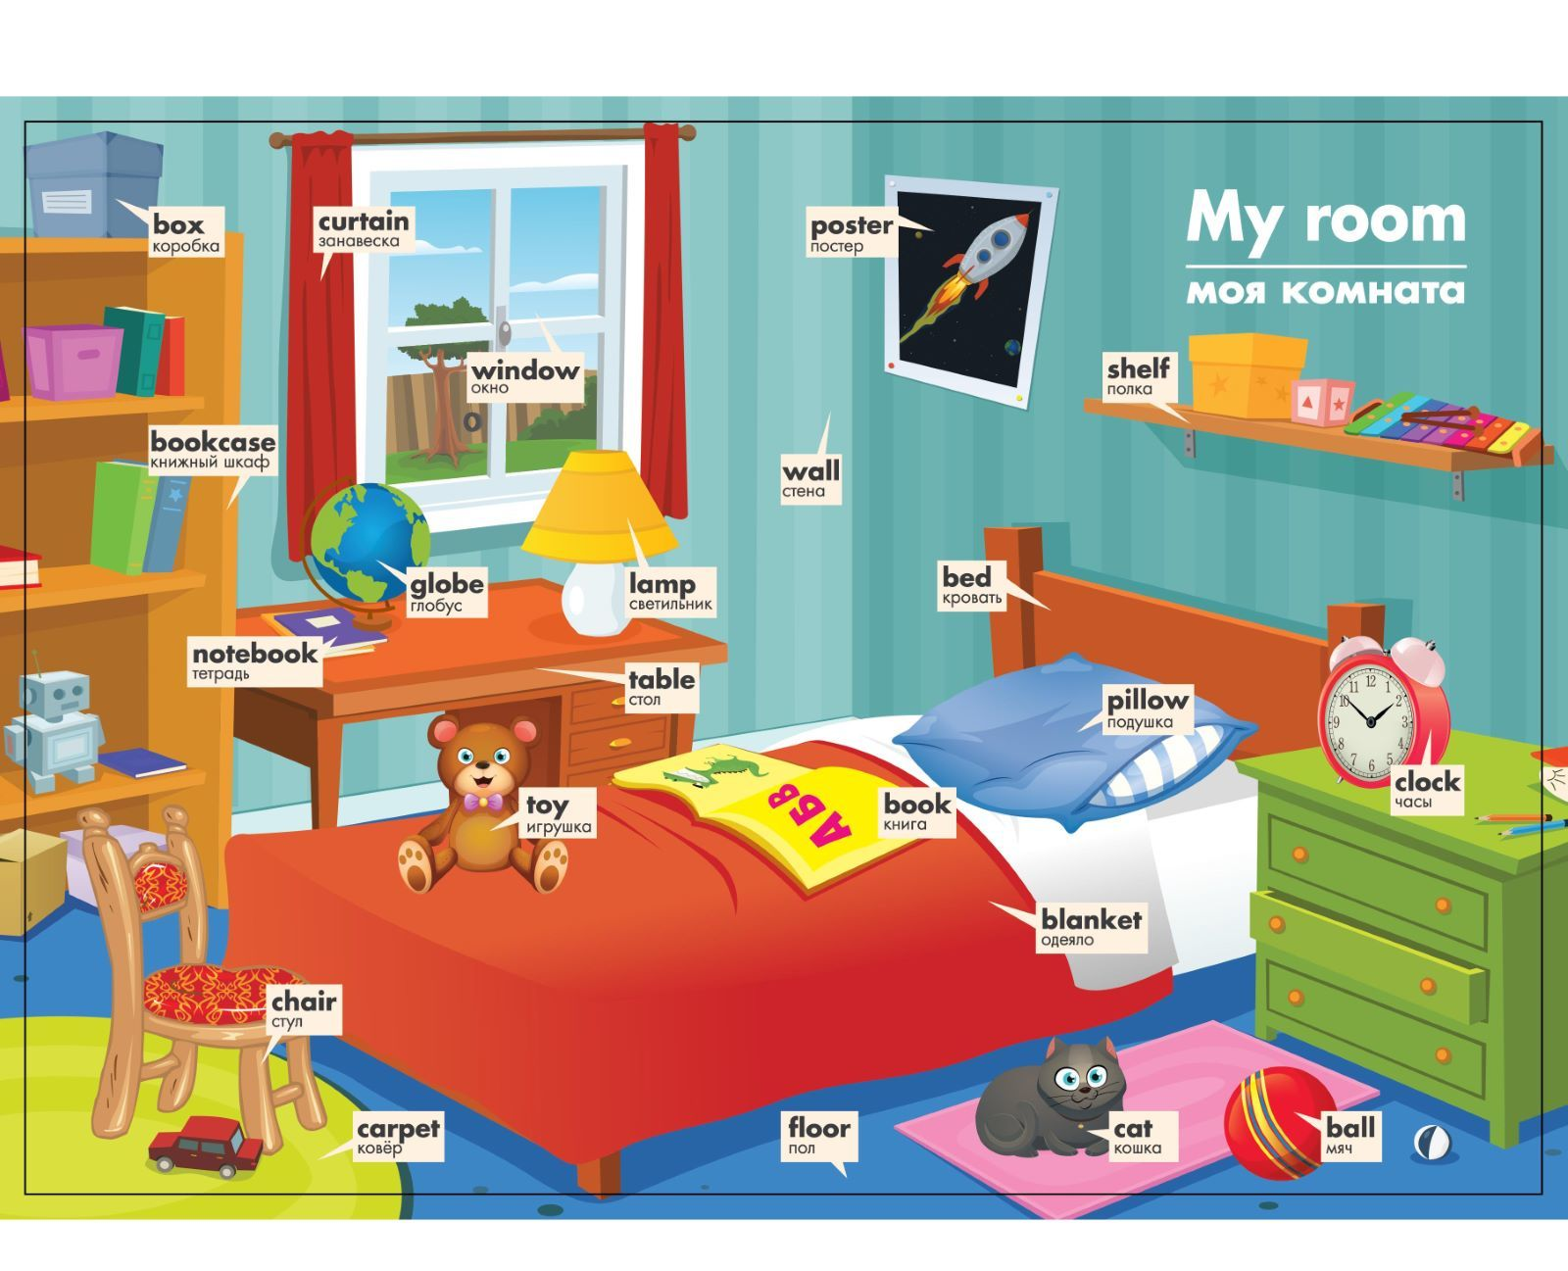
I live in a……
There are __rooms
Bedroom is my favorite room.
It is nice / large.
There is/are……
On the left there is/are…..
On the right there is/are……
In the middle of he room there is/are…..

№5 Фамилии начинающиеся с Ц по Ш
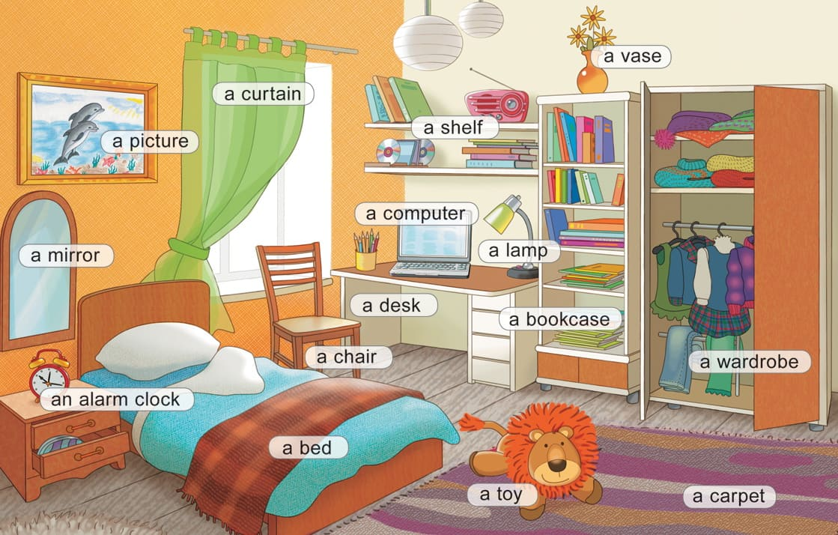

I live in a……
There are __rooms
Bedroom is my favorite room.
It is nice / large.
There is/are……
On the left there is/are…..
On the right there is/are……
In the middle of he room there is/are…..

№6 Фамилии начинающиеся с Щ-Я
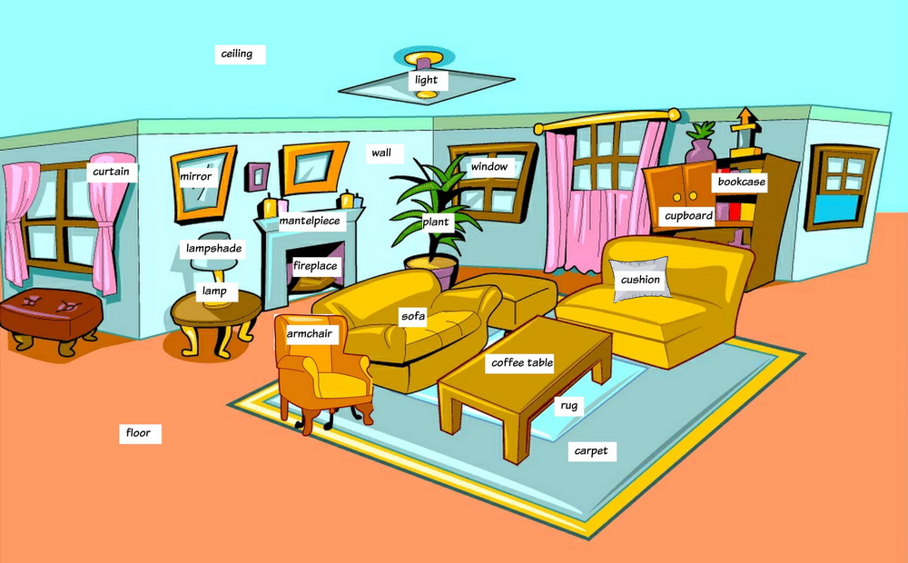

I live in a……
There are __rooms
Living- room is my favorite room.
It is nice / large.
There is/are……
On the left there is/are…..
On the right there is/are……
In the middle of he room there is/are…..

