Выписать и выучить слова упр.1, перевести текст «Meters», выполнить тестовое упр.3 (письменно)
1. a) Cover the right column and read the English words. Translate them into Russian and check your translation.
b) Cover the left column and translate the Russian words back into English.
meter | [ˈmiːtə] | измерительный прибор
battery | [ˈbætərɪ] | батарея
scale | [skeɪl] | шкала
readings |  | показания на шкале (прибора)
terminal | [ˈtəːmɪnl] | клемма
positive | [ˈpɔzɪtɪv] | положительный
negative | [ˈneɡətɪv] | отрицательный
to measure | [ˈmɛʒə] | измерять
to take into consideration |  | принимать во внимание
in this way | [weɪ] | таким путем, таким образом

2. Translate into Russian (see page 98):
1. One should take into consideration the difference between these circuits.
2. One should take into consideration that the ammeter is connected to the circuit in series.
3. What should one take into consideration using the ohmmeter?
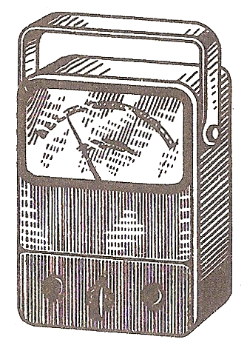
Meters
Fig. 3
Among the most common meters used there are the ohmmeter, the ammeter and the voltmeter. The ohmmeter is used to measure the value of resistance. It consists of a milliammeter calibrated to read in ohms, a battery and resistors. The meter is connected in parallel and the circuit is not opened when its resistance is measured. The readings on the scale show the measured value.
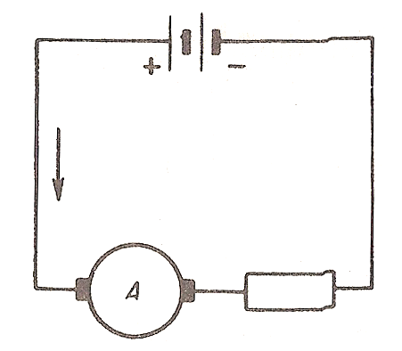
The ammeter is used to measure the value of current. When the ammeter is used the circuit should be opened at one point and the terminals of the meter should be connected to it. One should take into consideration that the positive terminal of the meter is connected to the positive terminal of the source; the negative terminal − to the negative terminal of the source The ammeter should be connected in series. The readings on the scale show the measured value.

Fig. 4

3. Complete the sentences using the correct variant:
1. The ammeter is | a) a common meter.  b) an uncommon meter.
2. In order to measure the value of current | a) the ohmmeter is used,  b) the voltmeter is used.  c) the ammeter is used.
3. A meter has | a) positive terminals only.  b) negative terminals only.  c) positive and negative terminals.
4. When the ammeter is used | a) the circuit should be opened.  b) the circuit should not be opened.
5. The ammeter should be connected | a) in series.  b) in parallel.
6. One should take into consideration that | a) the positive terminal should be connected to the negative terminal.  b) the positive terminal should be connected to the positive terminal of the source.

Выполненное задание переслать на почту gruzdeva-57@inbox.ru к следующему уроку

